
Science Policy

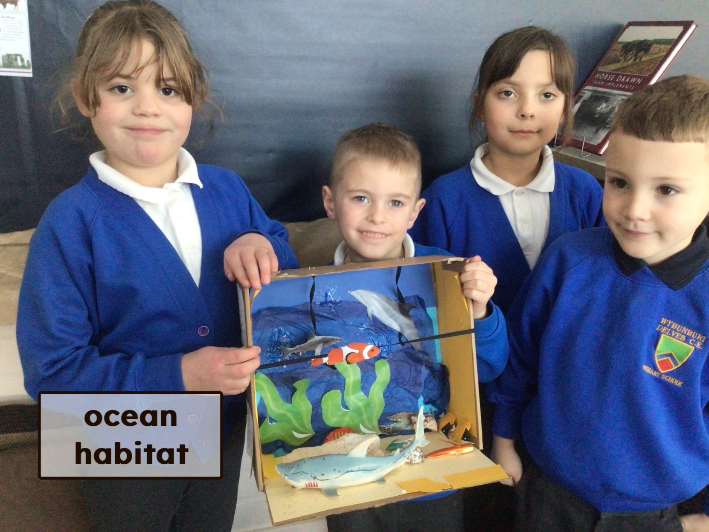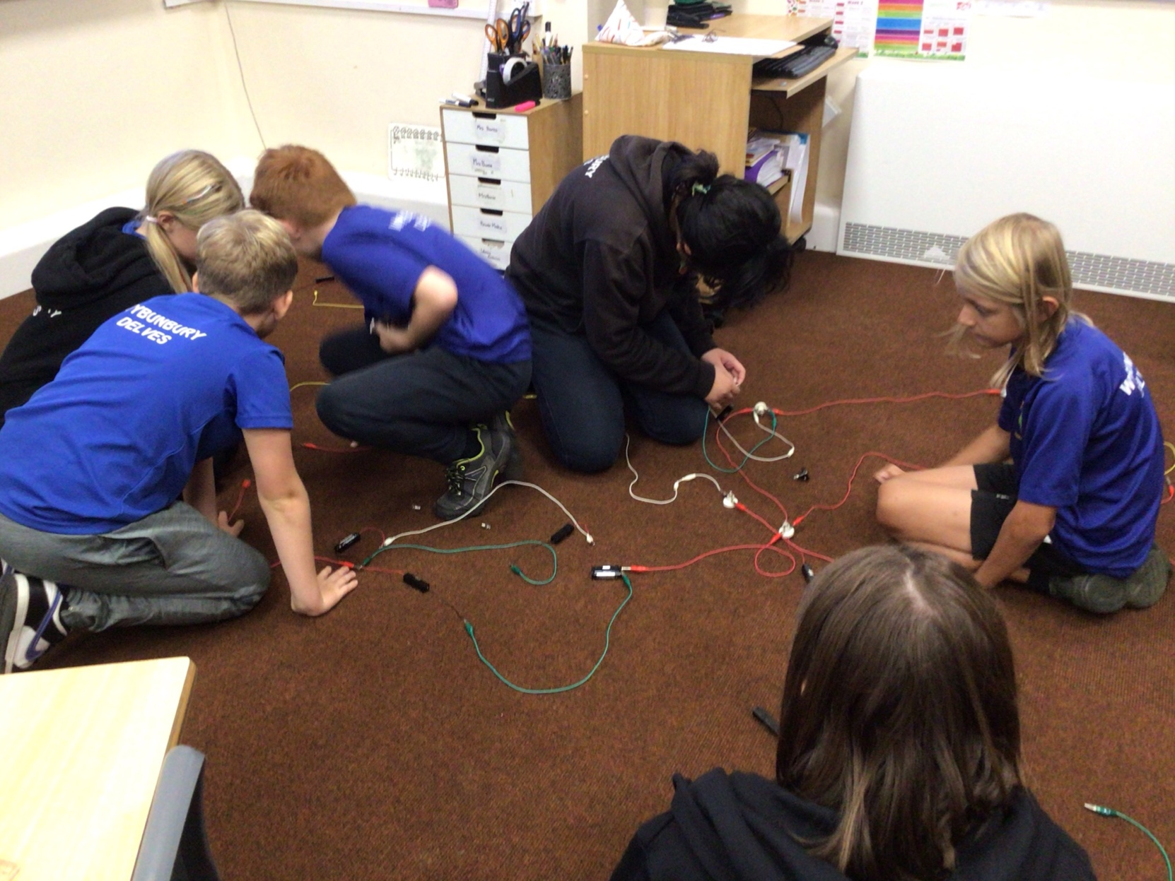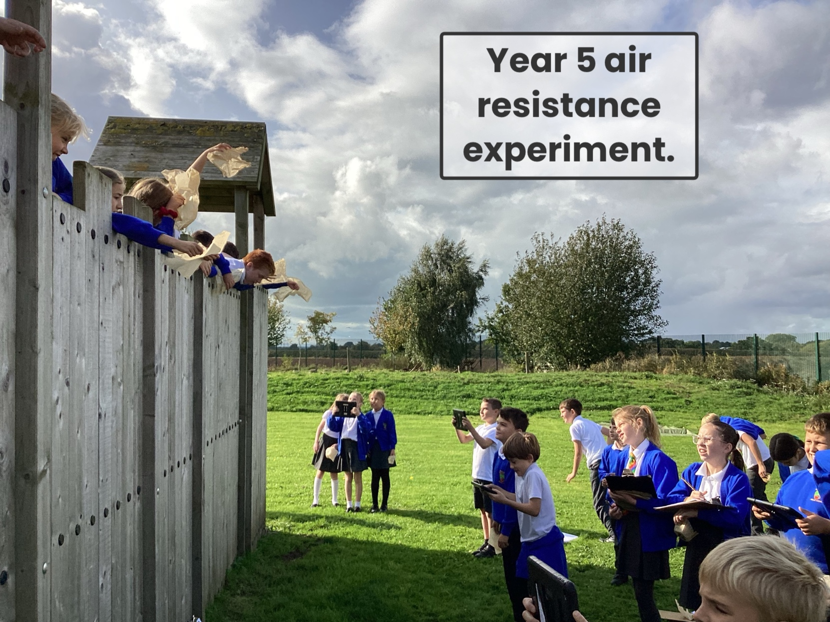
Rationale
At Wybunbury Delves we aim to ‘light the spark for a love of learning and of life’ and believe Science is a subject which offers the very best opportunities to achieve this. We work practically wherever possible to foster and maintain children’s curiosity in the world around them.
‘Equipped with his five senses, man explores the universe around him and calls the adventure Science.’
Edwin Powell Hubble
Curriculum Intent

At Wybunbury Delves, we follow the National Curriculum statements for Science closely. Therefore our intent for doing so aligns with the rationale behind the Science Curriculum within the National Curriculum itself, which is that: ‘A high-quality Science education provides the foundations for understanding the world through the specific disciplines of biology, chemistry and physics. Science has changed our lives and is vital to the world’s future prosperity, and all pupils should be taught essential aspects of the knowledge, methods, processes and uses of Science. Through building up a body of key foundational knowledge and concepts, pupils should be encouraged to recognise the power of rational explanation and develop a sense of excitement and curiosity about natural phenomena. They should be encouraged to understand how Science can be used to explain what is occurring, predict how things will behave, and analyse causes.’ Science at Wybunbury Delves aims to develop a fun, practical and engaging high-quality curriculum that inspires the next generation to succeed and excel in science. We do this through fully adhering to the aims of the national curriculum and fostering a healthy curiosity and interest in the sciences. At the heart of our progressive science curriculum is scientific investigation. Wherever possible we intend to deliver lessons where children learn through varied systematic investigations, leading to them being equipped for life to ask and answer scientific questions about the world around them. We believe science encompasses the acquisition of knowledge, concepts, skills and positive attitudes. Throughout the programmes of study, the children will acquire and develop the key knowledge that has been identified within each unit and across each year group, as well as the application of scientific skills. We ensure that the “Working Scientifically” skills are built-on and developed throughout children’s time at the school so that they can apply their knowledge of science when using equipment, conducting experiments and investigation, building arguments and explaining concepts confidently, being familiar with scientific terminology and, most importantly, to continue to ask questions and be curious about their surroundings.

The aims of Science in our school are:
- to promote and maintain curiosity about the world around us
- to develop children’s ability to pose, investigate and draw conclusions from scientific questions through practical tasks
- to develop and accurately use scientific language and vocabulary
- We work to the National Curriculum aims:
  - To develop scientific knowledge and conceptual understanding through the specific disciplines of biology, chemistry and physics
  - To develop understanding of the nature, processes and methods of science through different types of science enquiries that help them to answer scientific questions about the world around them
  - To ensure are pupils are equipped with the scientific knowledge required to understand the uses and implications of science, today and for the future

Curriculum Implementation
The acquisition of key scientific knowledge and vocabulary is an integral part of our science lessons. The progression of skills for working scientifically are developed through the year groups and scientific enquiry skills are of key importance within lessons. Our medium term plans allow for carefully planned, progressive units to be taught.. At Wybunbury Delves, teachers create a positive attitude to science learning within their classrooms and reinforce an expectation that all children are capable of achieving high standards in science.

Our whole school approach to the teaching and learning of science involves the following;

• Science will be taught in planned, and arranged, topic blocks by the class teacher. Our strategy is to enable all children to be catered for through adapted planning suited to their abilities.

• We plan for problem solving and real life opportunities that enable children to find out for themselves. Children are encouraged to ask their own questions and be given opportunities to use their scientific skills and research to discover the answers. This curiosity is celebrated within the classroom. Planning involves teachers creating practical, engaging lessons with opportunities for precise questioning in class to test conceptual knowledge and skills at the start and the end of a unit

• Our curriculum is progressive. We build upon the learning and skill development of the previous years, which is tested through questioning of the children’s prior knowledge where teachers can identify misconceptions that need addressing.

• Working Scientifically skills are embedded into lessons to ensure these skills are being developed throughout the children’s school career, and new vocabulary and challenging concepts are introduced through direct teaching. This is developed through the years, in keeping with the topics

• Teachers demonstrate how to use scientific equipment, and the various Working Scientifically skills in order to embed scientific understanding. Teachers find opportunities to develop children’s understanding of their surroundings by accessing outdoor learning and workshops with experts

• Through enrichment days, such as ‘science week’, we promote the profile of Science and allow time for the children to freely explore scientific topics. We also have scientists to come in to talk to the children about their area of expertise and give the children some real-life concept and understanding of what it is like being a scientist. Science trips, where appropriate to the unit, will also take place.

Curriculum & School Organisation (including time allocation)
KS1 and KS2 will aim to teach science for 1 hour a week. It will be integrated into their afternoon learning. Medium term planning will show the structure of the lessons for each topic and term. The learning outcomes will be evidenced on seesaw, smartboard files, powerpoint, website news, children’s books and photographs. We aim to teach Science as part of a broad and balanced curriculum. We seek every opportunity to develop Science with cross-curricular links to Maths, Literacy, Computing and Design and Technology and any other subject when suitable. Most science lessons will be suited to the class topics but if not the science will be taught as a discrete lesson.

Equality and Inclusion
All pupils regardless of gender, cultural heritage, race, colour, nationality, ethnic origin, religion or special needs, will be given the opportunity to experience and acquire skills according to the National Curriculum. We believe that we should aim to create an environment in which all children learn to respect and value each other and each other’s interests. This can be achieved by employing the following strategies:
- Mixing groups in terms of gender and ability.
- Setting suitable learning challenges.
- Structuring activities so all are fully involved. For instance, all children must have a ‘job/role’ within an activity to ensure everyone takes part and is involved.
- Responding to the diverse learning needs of pupils.
- Overcoming potential barriers to learning and assessment for individuals and groups.
- Considering the needs of children with physical or learning difficulties and taking the necessary steps (by enlisting extra help, adapting equipment or differentiating tasks) to ensure they have equal access to the curriculum.
- Giving all the children an opportunity to share their work. For instance, allowing time at the end of a lesson for the whole class to perform a role play, share their ideas or work with the class.
- Recognising the need to extend and provide a greater challenge for more able pupils.

Curriculum Enhancement Opportunities
Wybunbury Delves provides children with the opportunity to maintain curiosity beyond the classroom through outdoor areas, educational visits, and wherever possible, through visitors to school. Theme days and National Science Week also provide further opportunities to participate in Science.

Resourcing
Resources are centrally stored in our new Science Area and organised in clearly labelled boxes. These resources are accessible to all staff when required. Teachers are responsible for collecting and returning the resources. The contents of the resource boxes are updated annually after an audit of resources, and also on an on-going basis when teachers identify need.

Curriculum Risk Assessment
Staff are asked to use professional judgment with regard to pupil safety in individual lessons. Where it is deemed necessary, individual lesson risk assessments will be completed. The pro forma for this is in the Subject Leader folder on the t:drive. All staff have copies of the CLEAPSS guidance and access to the school Curriculum Health and Safety Guidance in the head teacher’s office.

Last reviewed: Lorna-Mae Haynes 18.03.24

